Low Level Design (LLD)

**Credit Card Defaulter Prediction**

Revision Number: 1.0

Last date of revision: 05/02/2024

Shridatta Patil

# Contents

Document Version Control ................................................................................ 3

1. Introduction ................................................................................................. 4
   1. Why this Low-Level Design Document? ................................................. 4
   2. Scope ..................................................................................................... 4
2. General Description ..................................................................................... 4
   1. Problem Statement & Product Perspective ........................................... 5
   2. Tools used.............................................................................................. 5
   3. Constraints ............................................................................................ 6

3 Architecture ................................................................................................ 7

* 1. Architecture Description ....................................................................... 8
  2. Error Handling ....................................................................................... 8
  3. Optimization ......................................................................................... 9
  4. Reusability ............................................................................................. 9
  5. Application compatibility ..................................................................... 10

3.6 Deployment ......................................................................................... 10

# Document Version Control

|  |  |  |  |
| --- | --- | --- | --- |
| **Date Issued** | **Version** | **Description** | **Author** |
| 05-02-2024 | 1.0 | First Version of Complete HLD | Shridatta |
|  |  |  |  |
|  |  |  |  |
|  |  |  |  |
|  |  |  |  |
|  |  |  |  |

# 1 Introduction

**1.1 Why this Low-Level Design Document?**

The goal of the Low-level design document (LLDD) is to give the internal logic design of the actual program code for the Food Sales Analysis dashboard. LLDD describes the class diagrams with the methods and relations between classes and programs specs. It describes the modules so that the programmer can directly code the program from the document.

## 1.2 Scope

Low-level design (LLD) is a component-level design process that follows a step- by-step refinement process. The process can be used for designing data structures, required software architecture, source code and ultimately, performance algorithms. Overall, the data organization may be defined during requirement analysis and then refined during data design work.

# 2 General Description

## 2.1 Problem Statement & Product Perspective

The dataset contains price information supplied on a weekly basis from 9thJune 2003 to 31stDecember 2018, since it is a time series data. The main goal is to forecast crude oil prices for the following years and months. Multiple services provided by a cloud provider will be used to trigger the Continuous Integration, Continuous Deployment including Continuous training of the model when any drift in data or pattern is observed.

## 2.2 Tools used

* Python programming language.
* Libraries such as Pandas, Numpy, Scikit-Learn, Matplotlib
* Framework: Flask
* IDE: Jupyter Notebook, VSCode.
* Cloud service: Heroku • GitHub.





* VsCode and Jupyter notebook is used as IDE.
* For Visualization of the plots Matplotlib is used.
* Heroku is used for deployment of the model.
* Front-end development is done using HTML/CSS.
* Python Flask is used for backend development.
* GitHub is used for version control system

## 2.3 Constraints

MLOPs on the cloud must be fully automated in consideration of continuous integration, continuous deployment with retraining approach of model, and archiving the data over time. Users can easily use the application and not needed to know any of the workings.

# 3 Architecture

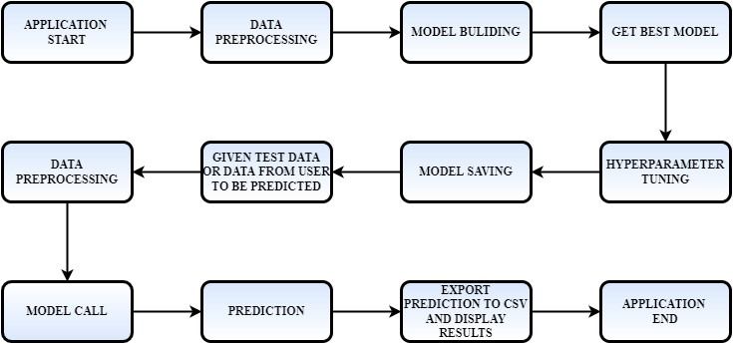

Figure 1: Process flow

## 3.1 Architecture Description

### 1. Raw Data Collection

The Data set was taken from Kaggle Provided Project Description Document.

### 2. Data Pre-Processing

Before building any model, it is crucial to perform data pre-processing to feed the correct data to the model to learn and predict. Model performance depends on the quality of data fed to the model to train.

This Process includes.

1. Handling Null/Missing Values
2. Outliers Detection and Removal

### 3. Data Cleaning

Data cleaning is the process of fixing or removing incorrect, corrupted, incorrectly formatted, duplicate, or incomplete data within a data set. a) Remove duplicate or irrelevant observations

1. Filter unwanted outliers
2. Renaming required attributes

### 4. Exploratory Data Analysis (EDA)

Exploratory Data Analysis refers to the critical process of performing initial investigations on data to discover patterns, spot anomalies, test hypothesis and to check assumptions with the help of summary statistics and graphical representations.

### 5. Reporting

Reporting is a most important and underrated skill of a data analytic field. Because being a Data Analyst you should be good in easy and self- explanatory report because your model will be used by many stakeholders who are not from technical background. a) High Level Design

Document (HLD)

1. Low Level Design Document (LLD)
2. Architecture
3. Wireframe
4. Detailed Project Report
5. Power Point Presentation

### 6. Modelling

Data Modelling is the process of analysing the data objects and their relationship to the other objects. It is used to analyse the data requirements that are required for the business processes. The data models are created for the data to be stored in a database. The Data Model's main focus is on what data is needed and how we have to organize data rather than what operations we have to perform.

## 3.2 Error Handling

The system should identify the errors encountered; an explanation will be displayed as to what went wrong? An error will be defined as anything that falls outside the normal and intended usage.

**3.3 Optimization**

Data strategy derives performance:

1. Filling missing values.
2. Replacing outliers.
3. Creating new features from dataset.
4. Hyperparameter tuning
5. Validating score again

## 3.4 Reusability

The code written and the components used should have the ability to be reused with no problems.

## 3.5 Application compatibility

The different components for this project will be using Python as an interface between them. Each component will have its task to perform, and it is the job of Python to ensure the proper transfer of information.